# Project Title: TRAFFIC MANAGEMENT SYSTEM-IOT

**PHASE 2:**INNOVATION

**SENSORS:**

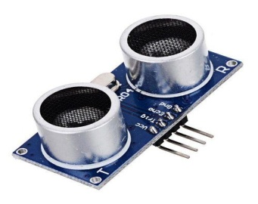

4 HC-SR04 ultrasonic sensors

**DEFINATION OF SENSOR:**

An ultrasonic sensor is a device that uses high-frequency sound waves, typically in the ultrasonic range (above the range of human hearing, typically above 20,000 Hz), to detect the distance or presence of objects. These sensors work on the principle of sending out a sound wave, which then bounces off an object and returns to the sensor. By measuring the time it takes for the sound wave to travel to the object and back, the sensor can calculate the distance to the object.

Ultrasonic sensors are commonly used in various applications, such as proximity detection, object avoidance in robotics, liquid level measurement, and distance measurement. They are known for their accuracy, reliability, and versatility in a wide range of environments.

**FLOW CHART:**

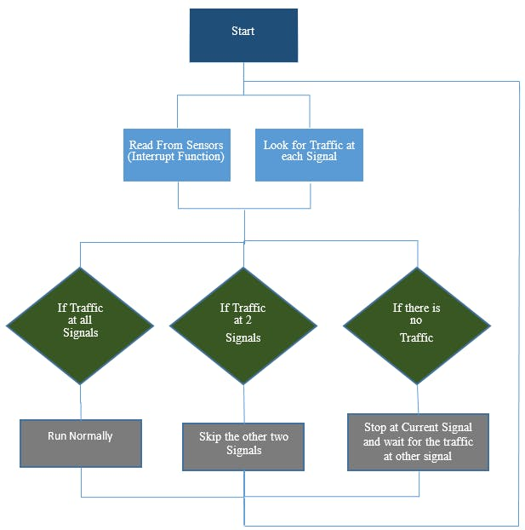

**BLOCK DIAGRAM:**

## Design & Construction of A Closed Loop Traffic Light Control System

**Block Diagram Description:**

**1.Power Supply:**

Provides power to the entire system. This could be batteries ,direct

power source.

**2. sensors:**

ultrasonic Sensor: Connects to the microcontroller to.measure density

**3.micro controller unit:**

This is the brain of the system, collecting data from sensors and process it and managing output actions and displays.

**4.Data Collection and Processing:**

The data from these sensors is collected and transmitted to a central server or cloud platform. IoT devices and communication protocols are used to ensure the data is transmitted in real-time.

**5.Traffic Control:**

IoT can be used to control traffic signals and manage traffic flow dynamically. Adaptive traffic signals can adjust signal timings in real-time based on the traffic data, optimizing traffic flow and reducing congestion.

**CIRCUIT DIAGRAM:**

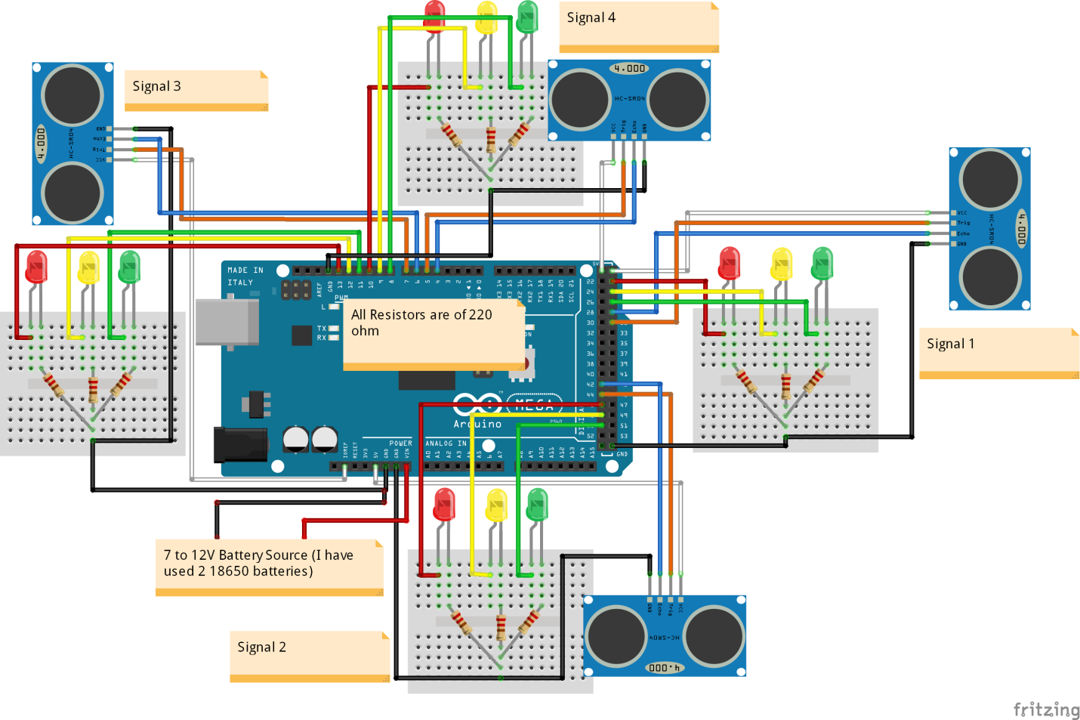

**APPLICATION:**

* **Traffic Control Centers:** Centralized traffic control centers monitor traffic conditions in real-time, making decisions and adjustments to traffic signals, signage, and other infrastructure to respond to changing conditions.
* **Smart City Initiatives:** Traffic management often plays a central role in smart city initiatives, where data from various sensors and cameras are used to optimize transportation networks, reduce energy consumption, and improve overall quality of life.
* **Emergency Services Coordination:** Traffic management systems facilitate coordination with emergency services, enabling ambulances, fire trucks, and law enforcement to navigate through traffic efficiently when responding to emergencies.

**CONCLUSION:**

traffic management is essential for optimizing urban transportation systems. It reduces congestion, enhances safety, and promotes efficiency. By integrating public transportation, improving pedestrian and cycling infrastructure, and employing smart technologies, traffic management contributes to cleaner, safer, and more accessible urban environments. It aids in environmental sustainability, fosters economic growth, and ensures a higher quality of life for city residents. As cities evolve, adapting traffic management strategies is paramount to meet the growing demands of mobility and to address the challenges of urbanization. Traffic management is an ever-evolving field that remains fundamental to modern urban planning.